Theoretical neuroscience: Exercise 4 The Hodgkin-Huxley model
Date: 28/11/19

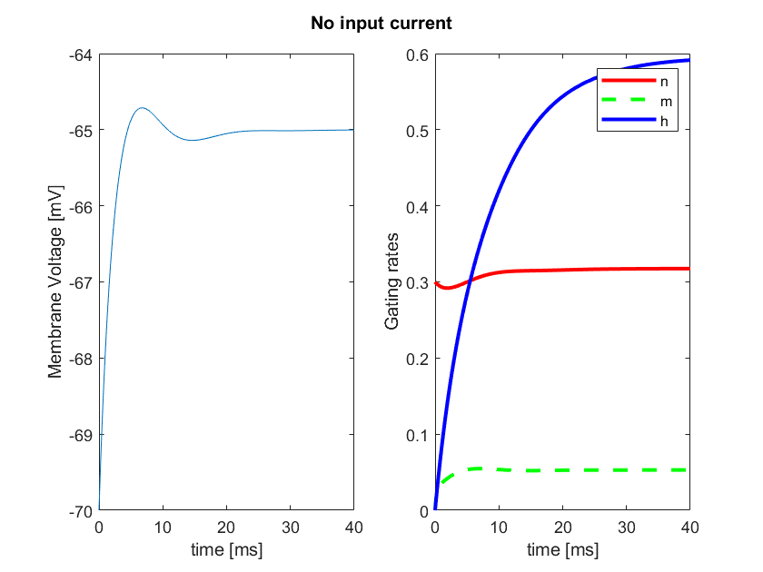

Figure 1: Membrane voltage and Gating rates (n, m, h) for constant input current 0mv, 0-40ms. Starting membrane voltage at -70mV, n rate= 0.3, m rate= 0 & h rate= 0 respectively.

We can observe that given no input into the system, the gating variables drive a small change in equilibrium towards a resting membrane voltage of ~-65mV. This appears to be primarily driven by an increase in the rate of the h gate, which is known to have greater probability of opening at lower negative membrane potentials.

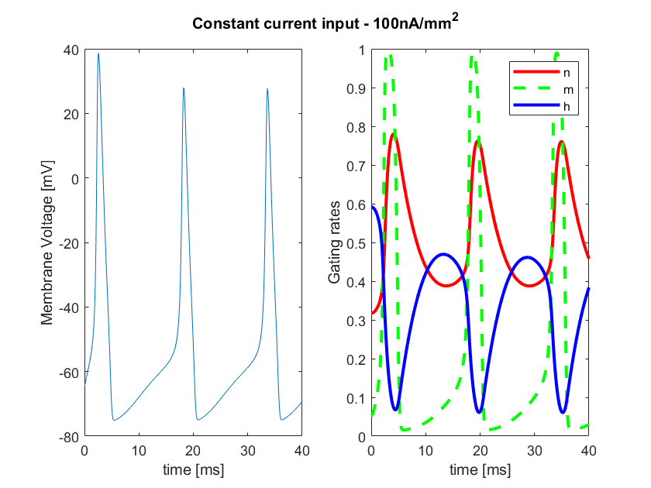

Figure 2: Membrane voltage and Gating rates (n, m, h) for constant input current 100mv, 0-40ms. Starting rates for membrane voltage at -65.00 mV, n rate= 0.32, m rate= 0.05 & h rate= 0.59, taken form the final steady state values in exercise 1.

In this exercise we see the system responding to a constant input current of 100mV with spiking (left), and the associated gating behaviour which varies in response to the changes in voltage (right). Initially we see, as membrane voltage increases, a rapid rate of increase in the m gate, thus increasing the opening rates for Na+ (m and h gates open). As this increases the membrane voltage to more positive values, the h gate responds by decreasing it’s rate and quickly halting the rapid Na+ influx – this acts as a perfect breaking mechanism for the rapid opening of the m gate. Additionally, the n gate increases with increasing membrane voltage, except slower than the Na+ gating. This slow K+ output from the cell begins to counteract the positive charge and repolarize the membrane potential, as the potential becomes more negative again, the n gate returns to a lower rate. With constant input these rates cycle through these states and continue to cause spikes.

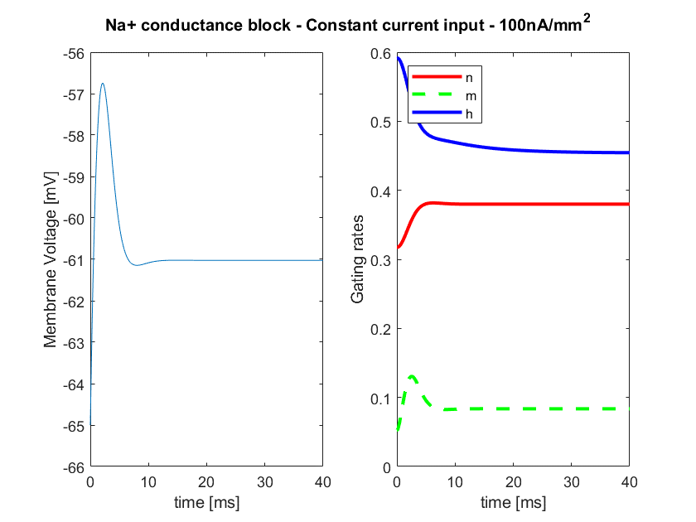

Figure 3: Membrane voltage and Gating rates (n, m, h) for constant input current 100mv, 0-40ms, with a Na+ conductance block. Starting rates for membrane voltage at -65.00 mV, , n rate, m rate and h rates, 0.32, 0.05 & 0.59 respectively, taken form the final steady state values in exercise 1.

By blocking the Na+ channel we observe a much smaller change in membrane potential (note smaller axis range), this small driving force comes from the leaky conductance which allows a small voltage change before the system is rectified by the n gate allowing K+ to bring the membrane potential to equilibrium.
We also see below in our equations, that removing the contribution of Na+ removes the powerful Na+ equilibrium potential driving the membrane voltage, thus there is a much smaller force, resulting in a smaller rise shown in figure 3.
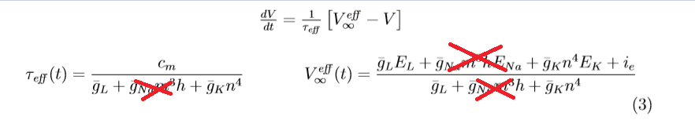

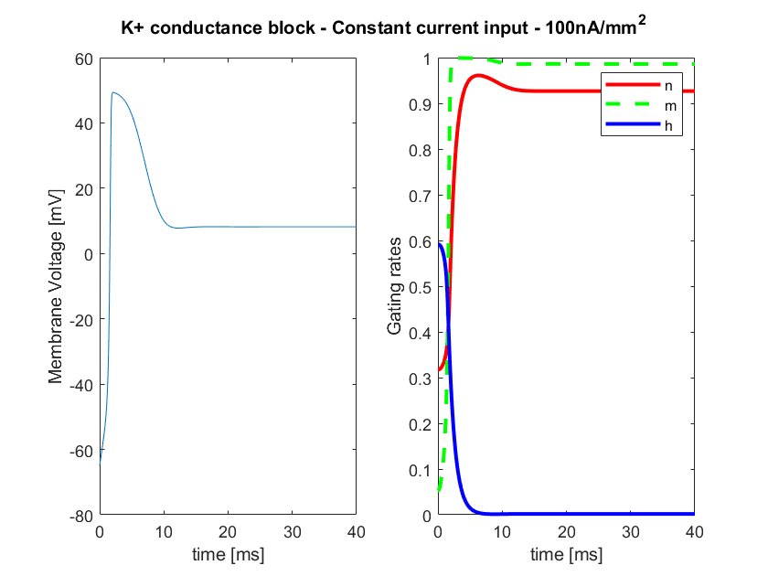

Figure 4: Membrane voltage and Gating rates (n, m, h) for constant input current 100mv, 0-40ms, with a K+ conductance block. Starting rates for membrane voltage at -65.00 mV, n rate, m rate and h rates, 0.32, 0.05 & 0.59 respectively, taken form the final steady state values in exercise 1.

Here we see the lack of K+ outflow to oppose the Na+ influx, gives the rapid rise in membrane voltage a steeper slope. Following a rapid spike and the correction of Na+ influx through the closing of the h gate, we can see that the membrane remains positive due to the lack of rectifying K+ outflow. And given the h gates lack of activity at these high voltages, we see a very low Na+ rate and an equilibrium reached at a positive membrane potential.

